**IBM ASSIGNMENT- I**

**TEAM ID :**

**NAME : PREM KUMAR.M**

**ROLL NO : 962919106003**

Create a circuit with Piezo alarm, Resistor,Relay,Photoresistor,Bulb with below functionalities:

1.This project demonstrates application of automatic lighting human interaction is less.Two physical quantities are controlled which are human motion and intensity of light.

**CIRCUIT LAYOUT:**

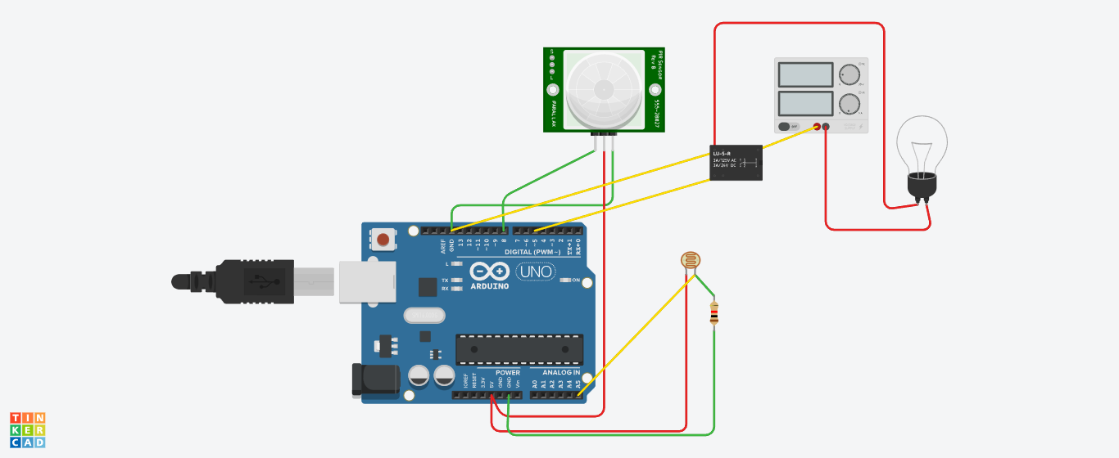

**CODE:**

float x,y ;

void setup()

{

pinMode(8,INPUT);

pinMode(5,OUTPUT);

pinMode(A5,INPUT);

Serial.begin(9600);

}

void loop()

{

x=digitalRead(8);

y=analogRead(A5);

Serial.println(x);

Serial.println(y);

if ( (x>0) && (y<550))

{

digitalWrite(5,HIGH);

delay(40000);

}

else

{

digitalWrite(5,LOW);

}

}

**OUTPUT:**

